f
Tech2globe Client Success Story - 2021

CASE STUDY
Online Business Growth
How Well We Understand Customer Business and Delivered Fruitful Results
Client Profile
- INDUSTRY: Retailer/Distributer
- BUSINESS MODEL: Online eCommerce Website & Store
- MARKETPLACE: Amazon, eBay, Onbuy (Website - Shopify)
- PRODUCT CATEGORY: Multi Categories

ABOUT CLIENT:

This client is a well-established online retailer who sells a broad selection of items ranging from electrical equipment to gardening tools, as well as other categories such as Home, Furniture, and DIY Decorative Items, and many more. They also have a seller account on Amazon, eBay, Onbuy, Walmart, and other ecommerce marketplaces, as well as a Shopify website.

CLIENT EXPECTATIONS:
They intended to attract a larger audience and sell their products on online ecommerce platforms. They needed a single solution to assist them expand their existing and new marketing channels. They do, however, desire a marketing automation system that offers outstanding customer support and is simple to use.

Client approached us to have his account managed professionally, and he was looking for an experienced Person/SPN/Organization who could understand his online eCommerce business and assist him with key factors such as Product Listings on Different Channels, Optimization, Promotion, Sponsored Ads, Sales Boost, and can operate "Multi Fulfilment Channel (Linnwork)."

They have a big plan to launch new items across all marketplaces, and they wanted their all-products details content/contribution to be as per marketplace guidelines, matching all attributes to target the right audience.
They set an expectation to keep the Product ID/the SKU's same across all marketplaces, and they wanted us to operate Linnwork tool to manage it.
Client was seeking for a service provider that could assist them raise brand recognition and work with an expert team to drive sales.
He believes in his goal of becoming a best seller on Amazon and other marketplaces, because he did not limit his capacity to grow inventory, they anticipated buyers to have a shop that could meet all their purchasing needs, potentially with several buying experiences.

CHALLENGE:
The main problem was completing a large number of product listings across all channels; the client wanted to sell as much inventory as possible on his platform, but they were having trouble getting category approval and selling their products with their brands on Amazon.

On the other hand, bringing his items to the top of the page was their first expectation, and using less budget for sponsored advertisements and marketing was a major concern for us. The most difficult task we faced was lowering the PPC spend-to-sales ratio in order to make their eCommerce business profitable. In several product categories, it had to fight against established eCommerce behemoths like Amazon and Onbuy, as well as eBay.

The client's product information was insufficient for fulfilling marketplace guideline and working with the search algorithm, therefore we had to use all macros of the available characteristics to fill in the data and make them SEO friendly. For this project, efficiency, professionalism, and a committed team with expertise were necessary to accomplish all tasks within the TAT and deliver the assignment with 100% accuracy.

THE GOAL:

- Cataloguing
- Sales boost
- Traffic & ranking
- Visibility
- Brand awareness
- Marketplace auth approvals
- Meeting client expectations
- Utilizing best practice and strategies
- Best analysis and marketing search
- More conversion

PROPOSED SOLUTION:
Our ecommerce experts performed a thorough assessment of the client's online business. It allowed us to gain a comprehensive picture of the client's ad expenditure, sales, and the interplay between them. The investigation also identified flaws that needed to be addressed. Giving the best solution & holistic service to our clientele is our specialty, which we successfully offer with the aid of our experienced staff, which is skilled in resolving customer problems and delivering the best results with efficiency.

For the best result we aligned a team on this project who has great understanding and highly experienced in ecommerce & well managed the bulk operation, especially dealing with omni channels and delivering maximum productivity with utmost sincerity, the team conducted an experiment to determine which extensive approach would help to complete this project! and we leveraged our skills to deliver this job on time.

Our work pattern is dynamic, & completely fact driven. Before commencing work, we research project objectives, expectations, and strategy before beginning work to ensure our clients' success.

For optimal outcomes, target the following major points with a well-established approach.

- Inventory analysis
- Preparing raw data for bulk operation
- Product details proofreading
- Collecting all possible details
- Best keywords strategy
- Targeting all relevant attributes
- Focusing on product visibility
- Detailed plan for executing
- Market competitive analysis
- Using all key aspects for best result
- PPC management/promotional activity
- Targeting audience
- Brand awareness

HOW IT BEGINS:
- Begins with day-to-day communication with client to understand his expectation and business process.
- Preparing analytic report of the previous listings structure.
- Categorized the products to use the universal content for the similar listing to save the time.
- Prepared the master file of the listings to utilize in different marketplaces as per the existing template.
- Finalize the data and get approval from the client on the template.
- Get done the listing in batches to speed up the process.
- Explored the new sales boost opportunity on seller central to boost up the sales volume.
- Verified the uploaded data and rectify the issues.
- Compare the product ranking over the ecommerce buyer page of his all marketplaces.
- Analyzed the Top competitors and generate a report for best strategy.
- focused on selling higher priced products to decrease the spends-to-sales ratio.
- To scale campaigns at the right time, we kept a careful eye on competitive prices, offers, and stock levels.
- Remarketing strategies that are strategically employed and based on site users' prior activity or search patterns.

LIST OF TOOLS WE USED:

Tools we used for BSR/Competitive Analysis:
- Helium 10
- Amazon & Other Marketplace Pages Analysis
Tools we used for Keywords Strategy:
- Helium 10
- Sonar
- Online Keywords Research Tools
- Marketplace Search Results
Tools we used for Multi-Channel Fulfillment:
- Linnwork
Tools we used for Inventory Management, Order Management:
- Linnwork
- By Marketplace itself

BIWEEKLY FEEDBACK CALL WITH CLIENT:
To make our work specific and maintaining 100% accuracy we a have module for the “Bi-Weekly Feedback Calls” where we discuss the improvement areas with client and request them to share their valuable feedbacks on our performed task, this practice makes client insight clear for us to understand their expectation and we can set the next goal on each call to achieve our targets efficiently.

RESULT:
Hard work always pays, and our team's consistent, thorough, and well-coordinated efforts worked splendidly in this situation. Our campaign aims exceeded the client's expectations, as overall spends-to-sale decreased dramatically while we maintained our sales targets successfully. Built up the goodwill on the online marketplace within the targeted date and client appreciated our efforts we put to deliver this job on time with 100% accuracy. Below are the examples of the Sales numbers achieved.

TEAM MEMBERS WHO WAS MAJOR PART OF THIS PROJECT TO MAKE IT SUCCESSFUL:
- Manager (Job: Analysis, Suggestion, Approval, Meetings)
- Team Lead (Job: QA, Suggestion, Proofreading, Client Calls)
- Listing Cataloguer
- Content Writer
- PPC Manager



Sales comparison on monthly basis from July 2020 to June2021:

Month | Year | Total Sales (£) | FBA Sales (£) | MFN Sales (£) | Total Order | FBA Order | MFN Order
July | 2020 | 164,343.72 | 374.75 | 163,968.97 | 11,870 | 25 | 11,845
August | 2020 | 153,407.74 | 8,353.58 | 145,054.16 | 10,693 | 573 | 10,120
September | 2020 | 125,364.71 | 16,955.78 | 108,408.93 | 8,619 | 1,285 | 7,334
October | 2020 | 127,976.33 | 17,387.49 | 110,588.84 | 7,996 | 1,192 | 6,804
November | 2020 | 155,897.62 | 4,647.28 | 151,250.34 | 10,081 | 422.00 | 9,659
December | 2020 | 188,915.75 | 6,935.62 | 181,980.13 | 10,990 | 604 | 10,386
January | 2021 | 176,280.57 | 6,097.24 | 170,183.33 | 10,402 | 724 | 9,678
February | 2021 | 125,399.03 | 5,487.57 | 119,911.46 | 8,291 | 716 | 7,575
March | 2021 | 229,474.38 | 5,099.57 | 224,374.81 | 12,890 | 661 | 12,229
April | 2021 | 310,247.25 | 3,722.08 | 306,525.17 | 310,247 | 460 | 15,638
May | 2021 | 285,776.78 | 7,516.52 | 278,260.26 | 12,288 | 759 | 11,529
June | 2021 | 352,965.33 | 26,198.73 | 326,766.60 | 16,032 | 2,036 | 13,996

Product listed on different channel by our team:
Matrices |  | Completed Product Listing
Sr. No. | Panel | With Variation | Without Variation
1 | Amazon | 2996 | 2314
2 | Shopify | 3220 | 2507
3 | OnBuy | 2384 | 2233
 | Total | 8600 | 7054
 | Grand Total | 15654

Following the synopsis of the 6 months sales comparison: (July 2020 to Dec 2020) (Jan 2021 to July 2021)
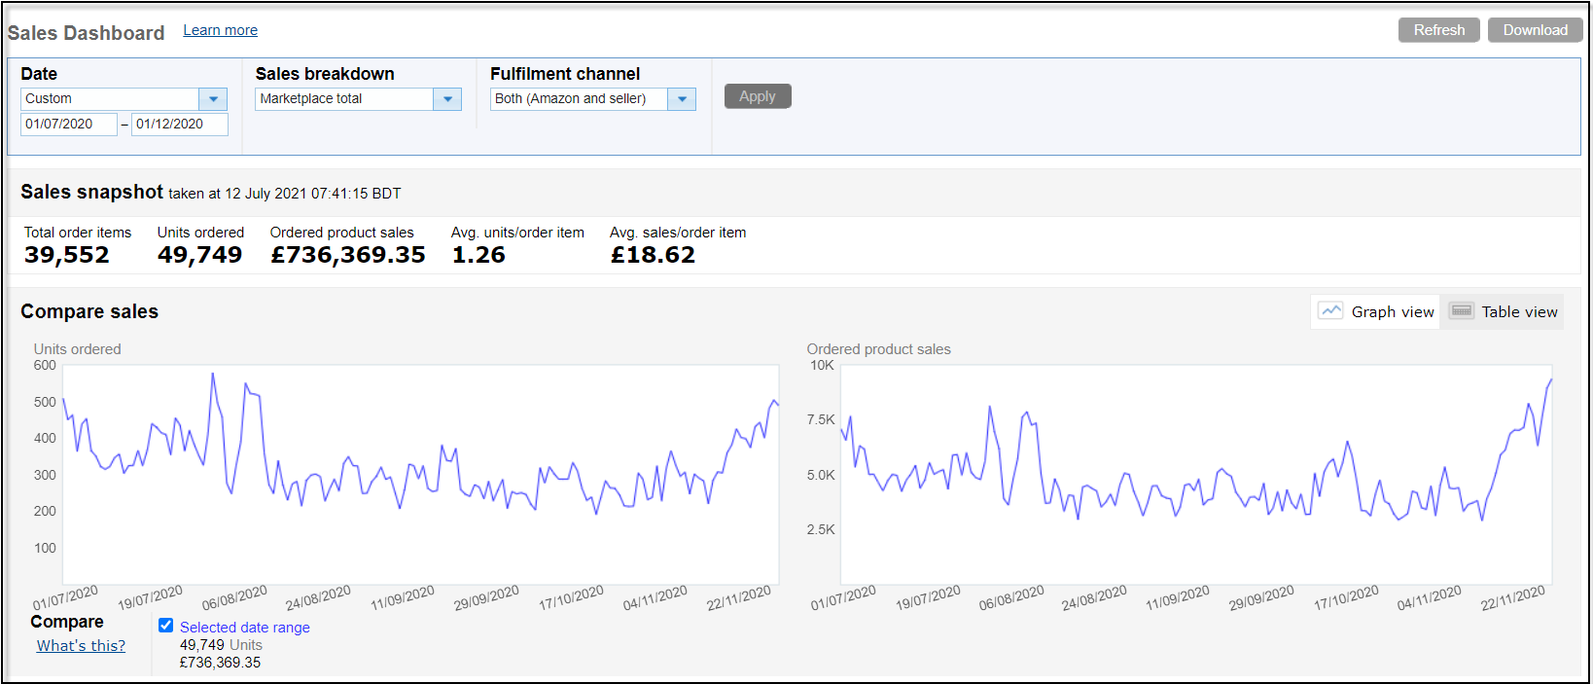
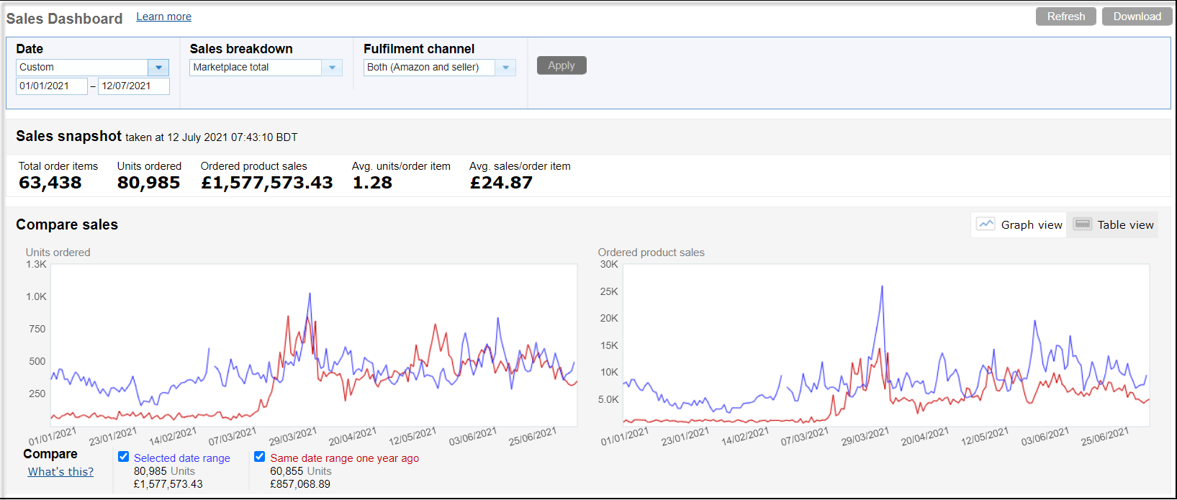
Feedback Report – 4.8 Rating (Positive 98%)
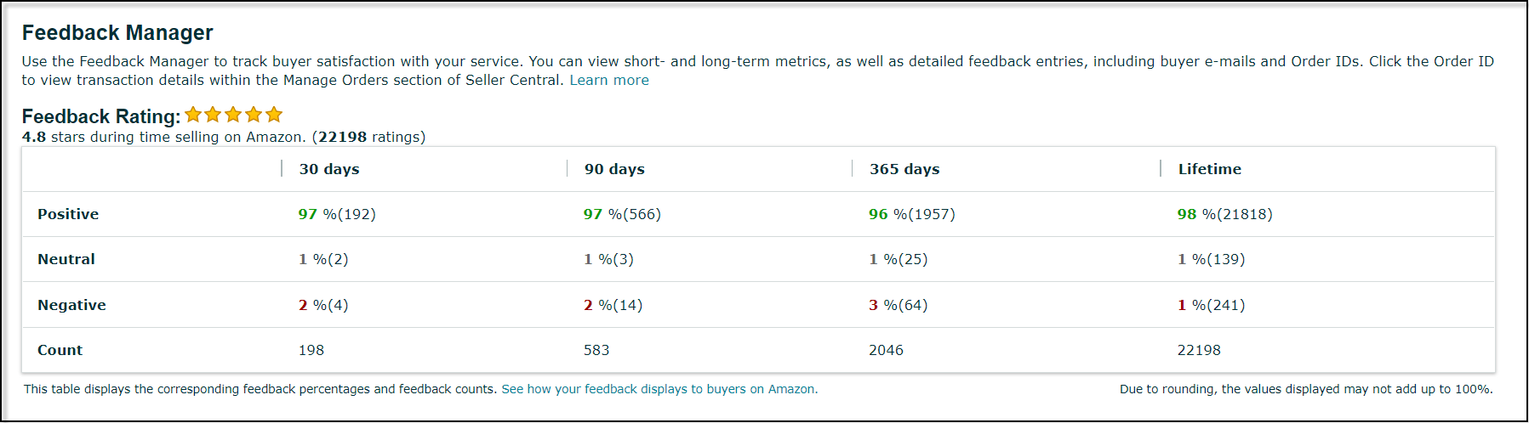
Thank You

